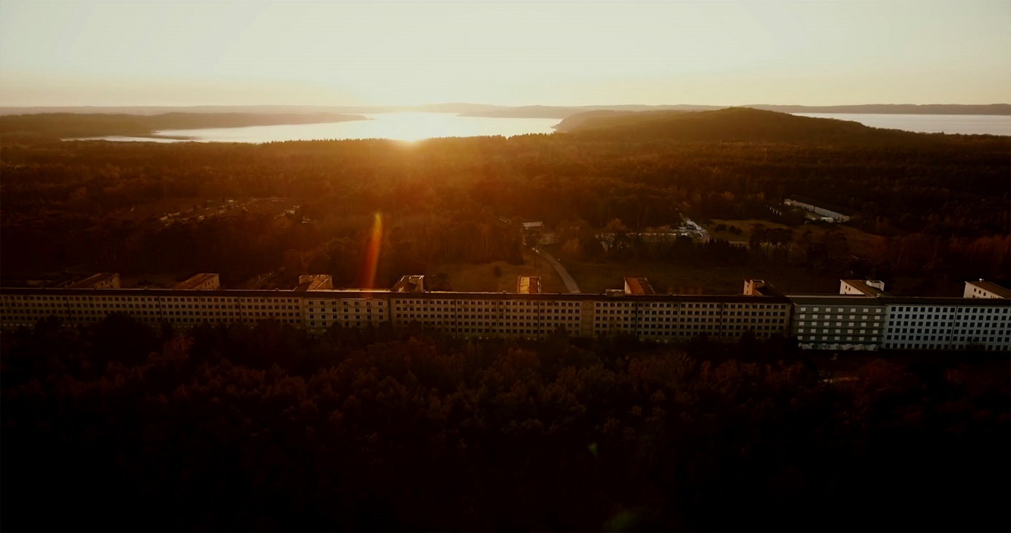
© NOW Collective 2019

PRESSKIT INSIDE PRORA

A film by Nico Weber
A NOW Collective Production, Berlin (Germany)
World premiere 2020

Table of contents

Synopsis 1
Crew 3
Technical specifications 3
Contacts 3
About the film 4
Director`s Note 6
Camera & Edit 7
Music 9
Featuring (selection): Peter Eisenman, Marco D'Eramo, 9
Rainer Eppelmann, Ulrich Busch, Justinian Jampol, Eric Zuelow etc.
Biographies (Nico Weber, Marc Nordbruch, Ralf Merten, Lukas Schwarzkogler) 12
Press release 16
Credits 18

www.inside-prora-film.de

SYNOPSIS

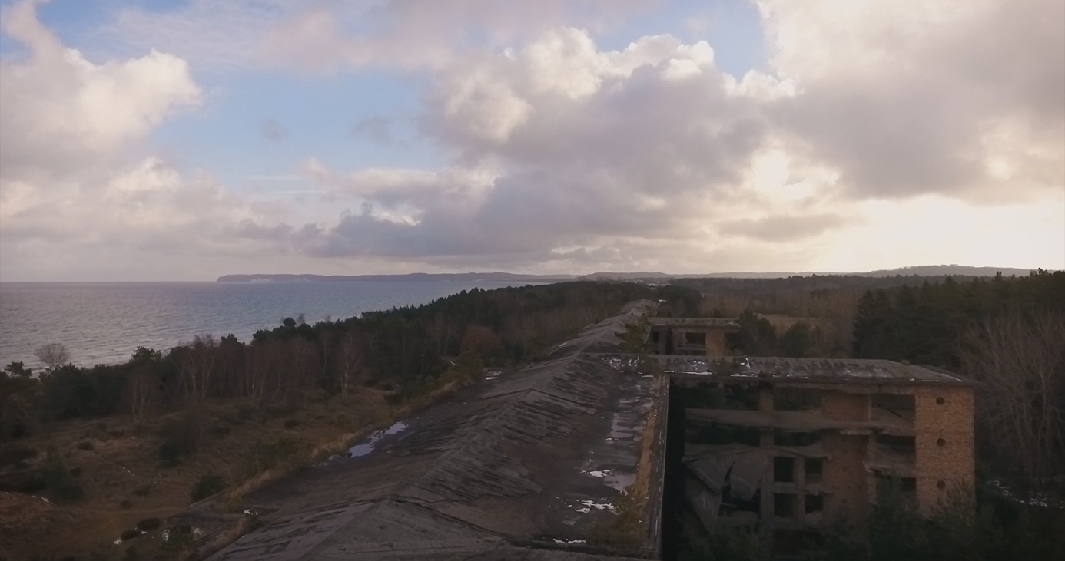Large parts of the building complex still bear witness to past epochs, casting their shadows into the present. © NOW Collective 2019

Known as the “Monster by the Sea” and the “Colossus of Rügen”, Prora is considered the longest building in the world. Built during the era of National Socialism, it was converted to one of the largest barracks in the GDR after the Second World War and became an abandoned site for many years following Germany’s reunification. Now hotels and holiday homes are springing up in the heritage-protected complex on one of Germany’s most beautiful beaches.

This film tells the story of these historic transformations, from Hitler to Honecker and the Cold War and into our time. However, the film is not about historical completeness. Instead, it focuses on historical ellipses and their embroilments with human biographies. It breaks with the conventions of a historical documentary film and goes far beyond them.

For the first time, the bizarre building complex is the protagonist in a movie. INSIDE PRORA feels its way through this gigantic labyrinth, peeling back the layers of history and establishing connections – sometimes unexpected – between people and societies with modernist architecture and the phenomenon of mass tourism.

The film takes us on a journey through time and space – and yet always returns to Prora. Director Nico Weber creates extraordinary cinematographic moments in the impressive images of her cameraman Marc Nordbruch and interweaves historical images to create a breathtaking synthesis that reveals the essence of Prora, tracing its architectural origins in Italy and establishing references to New York skyscraper architecture.

INSIDE PRORA has no narrator. The film relies on the images of cameraman Marc Nordbruch, the music of Ralf Merten and conversations with people who are directly or indirectly connected with Prora. These include:

Peter Eisenman, designer of the Holocaust Memorial in Berlin. The top New York architect addresses the topic of architecture during Fascism and National Socialism.

Rainer Eppelmann was the last defence minister of the GDR, despite refusing military service in the 1960s as a “Bausoldat” a “construction soldier”.

Marco d’Eramo, sociologist and philosopher, explores topics including mass tourism and architecture in great depth.

Justinian Jampol has dedicated himself to the era of the Cold War. The Californian historian is the director of The Wende Museum in Los Angeles. The Californian archive and museum houses the world’s largest collection of Cold War iconography.

Eric G. E. Zuelow is a professor at the University of New England (Maine, USA), a specialist in European history and a researcher analyzing the history of mass tourism.

Ulrich Busch initiated today’s development as a real-estate project developer by acquiring the first two blocks at Prora. He is the son of Ernst Busch, communist singer of workers’ songs and GDR icon.

Also:

Wim Cox, photographer, artist and archivist;
Antonio Ghionzoli, architect;
Romy Guruz, Head of the Binz Building Department;
Vittorio Magnago Lampugnani, architect, professor emeritus for the history of urban planning, architectural theorist;
Hendrik Liersch, former “Bausoldat” (construction soldier);
Katja Lucke, Director of the Prora Documentation Centre;
Susanna Misgajski, Director of the Prora Centre;
Massimo Ricci, Managing Director Riminiterme

(Protagonists can be found under www.inside-prora-film.de)

INSIDE PRORA combines seemingly disparate images and events, piecing them together in order to form the big picture.

The film celebrates its world premiere in 2020, 30 years after German reunification. That event is a significant source of inspiration for the film team, because INSIDE PRORA is also a film about the German culture of remembrance and German culture of repression. However, it also allows itself to look far beyond the horizon and explore the phenomenon and fascination of this monumental building on an international level.

The film raises crucial questions:

Is Prora the happy ending
of a story now overcome?

Does Prora still represent the irony of history?
Or is it already a symbol of its triumph?

CREW

Writer, Director and Producer: Nico Weber
Cinematographer and editor: Marc Nordbruch
Music Composer: Ralf Merten
Visual Effects Supervisor: Lukas Schwarzkogler
Line Producer: Jörg Leine
Editorial Collaborators: Jörg Leine, Heiko Kreft
Featuring: Peter Eisenman, Marco D'Eramo, Rainer Eppelmann, Ulrich Busch, Justinian Jampol and many more

TECHNICAL SPECIFICATIONS

Length: 100 min
Size: 2D DCP
Color: Color & Black & White
Screen size: Full Container
Sound Format: 5.1
Original Language: German/English/Italian
Translation: Spanish, Mandarin

CONTACT

Production
NOW Collective GmbH & Co.KG
CEO Nico Weber
Arndtstraße 39
10965 Berlin
phone +49 (030) 69517747
office@nicoweber.com

Press and public relations
Susanne Tenzler-Heusler
brandvorwerk-pr
phone +49 (0)173 378 6601
kontakt@brandvorwerk-pr.de

ABOUT THE FILM

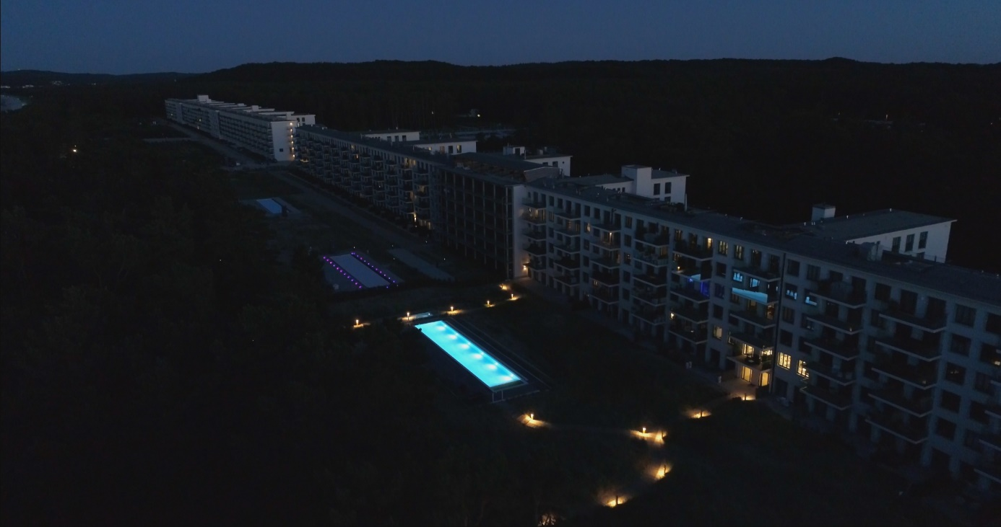
Prora in transformation: a Baltic seaside resort is being built here, as originally intended by the Nazis. © NOW Collective 2019

Some are fascinated by its architectural radicalism: modernist, rationalist and monumental. Others hate the building and regard it as highly toxic because of its dark history. Prora, the second largest architectural legacy of the Third Reich after the Nuremberg Reich Party Rally Grounds, is polarizing.

The longest building in the world stretches along 4.5 kilometers of Germany’s Baltic coastline on Rügen. Prora tells us its, and our, story: planned by the Nazi regime as a Strength Through Joy seaside resort, military barracks of the GDR dictatorship, future Baltic seaside resort. "Monster by the Sea", "Colossus of Rügen", "Führer Block" – its nicknames testify to its superlative status as well as its macabre potential.

It is hard to imagine a more forceful symbol of the turbulent history of Germany over the past near-century. Here are the powerful ideas and ideologies that gripped Germany and the whole of Europe in the past hundred years: the racist delusions of fascism, the rise of socialism, world revolution and class struggle; capitalism, individualism and the power of money. Is the battle between social and economic systems of the 20th and 21st century ingrained in the very stones of Prora?

The film INSIDE PRORA approaches this focal point of our history in a new and unusual way. Instead of following the common principle of linear historical documentaries, it resembles a journey into the unknown.

INSIDE PRORA is a cinematic essay that revolves around this unusual architectural structure. Extending beyond Prora, it changes our perspective of this unique place. The building also speaks to us, draws us into its spell, captures us, leaves us with a web of very diverse narrative strands, with individual truths and confusions.

INSIDE PRORA feels its way through the gigantic labyrinth, seeming to lose itself in space and time and between different people. And yet the film always returns to Prora, at the centre like a magnet, leaving a wake of people and their lifelines that connect with the building and its history. INSIDE PRORA excavates and exposes stories on several levels: historical, aesthetic and psychological.

INSIDE PRORA consciously seeks to communicate its own visual experience by connecting and correlating images and events that seem disparate at first, yet are linked by identifiable connections at second glance. A kaleidoscope falls into place as the whole picture. The film goes in search of references and connections through the historical layers, between people and places. It casts an international net in investigating similarities and parallels to Prora and the transformations undergone by the place.

For the first time, INSIDE PRORA sheds light on major historical lines of development such as transnational mass tourism, which was anticipated in Prora on a more monumental scale than in any other place.

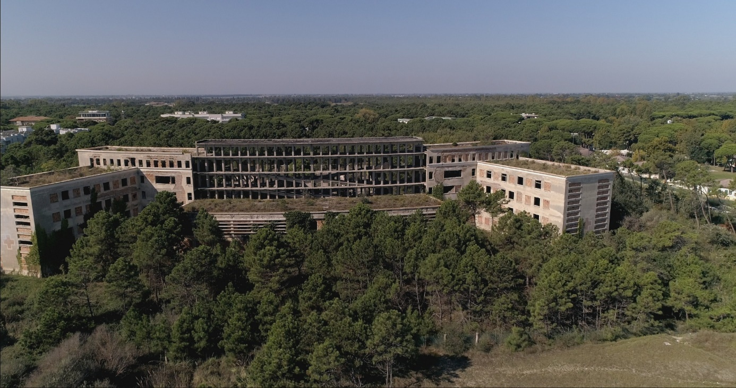
Colonia Marina Varese, Cervia (south of Ravenna) as a model for Prora: The National Socialists borrowed the idea from Mussolini's holiday homes for children. © NOW Collective 2019

INSIDE PRORA also reveals that Prora was not a German invention. Mussolini's children's holiday camps, aimed at honing physical fitness and indoctrination of young people, were an important inspiration for the German Nazi leisure organization Kraft durch Freude (KdF; “Strength Through Joy”), modelled on the Fascist leisure organization "Dopolavoro". Is it possible that a double-edged, deep-rooted yearning of the Germans for Italy was manifested in the stones of Prora? Is there more to this yearning than sun, sea and sand?

The gigantic scale of the planned KdF seaside resort on Rügen also reveals something of the history of modern architecture. This place is hardly conceivable without the “linear city” concept of 19th-century Russian architects, delivering inspiration for the innovations of the Bauhaus and the great utopias of Le Corbusier. In architectural and conceptual terms, the "Colossus of Rügen" falls within the logic of New York's skyscrapers: Prora, the horizontal skyscraper.

INSIDE PRORA tells German-German history on the one hand while, on the other, presenting its narration in an international context. Using special artistic techniques, the film explores various complex phenomena of 20th- and 21st-century history, thus penetrating the tacit assumptions from which architecture draws its strength.

DIRECTOR’S NOTE
NICO WEBER

Prora is one thing above all else: big.
Too big. Too banal. Too ambivalent.
Too big to tear down. Too big to talk about without leaving gaps.
Impossible to simply get rid of.
This is true for many people who are directly involved with Prora.
And it’s true for me too; that's why there are so many beginnings to this story that I could tell.
They are all true, and yet none are enough to identify the points of the beginning and the end.
The place and the buildings are full of stories
with as many truths as lies.
One more bizarre than the other.
Prora is full of contradictions. Contradictions that are not painful enough to induce a clear-cut attitude.
Prora is a question-mark. That is something that has appealed to me. Right from the start.

Good films don't have to give answers. Good films have to ask questions.
It is not necessarily important to know what you will find, but what you are looking for.
This doesn't fit into a results-oriented supply culture.
Especially not in the genre of documentary film.
I am not a documentary filmmaker. I am a filmmaker.
I am usually only interested in the documentary genre if it brings together the documentary and the imagined in a productive way.
When it takes the risk of presenting complex montages in astounding streams of images and sound.
When it embraces risk.
By seeking contemporary forms of expression, by exploring interest in cinematographic experimentation.
Circling. Complexity. Radical subjectivity, perhaps.
A language of its own.

In this respect Prora as a building is a landscape of souls, not only because of its size and structure, but determines the structure of the film at the same time:
Dig Deep! and Think Big!
After all, history is not merely what has happened, but what has been stratified.
INSIDE PRORA fits. It did so from the beginning. When the film began to grow.

I was there for the first time in 2013. But Prora was a no man's land when I first heard about it. So it took time.
I was standing in the decaying part of block 5, in an almost endless passage which ended somewhere far out of sight. An encounter that felt surreal to me.
Thinking about the building’s developer: Robert Ley.
He was to be charged in Nuremberg as one of the main war criminals from the Third Reich. He had built Prora for Hitler, a choleric alcoholic. Ley hanged himself sitting on the toilet. Just in time. Could his end have been any more pathetic?

My films, the stories, come to me in scraps and shreds of pictures. Sometimes I do research. I can't help it. I collect pictures. Sometimes the thread slips away again.
Until several pieces of the puzzle come together.
There is always an impulse, something that triggers me.
With Prora there were several. Including a surreal encounter with an old man with a dog: "You Westerners! You are destroying the whole beach!”
A feeling like being at the end of the world.
The road went no further for GDR citizens.
Yet it was the beginning of the world for the National Socialists. "Strength Through Joy" was a scheme to strengthen the masses, preparing them for a war of conquest against the rest of the world.

Here it is: the whole panorama of German history.
Here I also met the "rest of the world". People who came here to see Prora. Looking at this strange place from "outside" and "inside". Understanding what inspires my fascination too, what simultaneously attracts and repels me.
And this is only the beginning of the story.

But it’s also another story.

CAMERA/ EDIT
MARC NORDBRUCH

Being invited to shoot and edit a film is a special privilege for me.
I can tell stories with pictures. I have been working as a freelance editor since 1998, and as a cameraman since 2007.
In this combination, I am mostly involved in the projects from the beginning, from the idea to the completion.
During a shoot, there are moments after a scene when I switch off the camera with a smile because I have the feeling that something special just happened.
It just fits.
The lighting, the action, the protagonists – what they said, how they stood, how the image worked.
Everything.
That makes me really happy.
During editing, I am mesmerized by certain scenes over and over again because they move me, because they function in an unusual way. Sometimes it takes a while to get there.
And it's often a lot of work to get to that point.
As with INSIDE PRORA.
I've been working with Nico Weber for a long time.
We are a well-oiled team when it comes to shooting.
Few words are necessary.
When it comes to editing, we talk all the more.
With INSIDE PRORA, we didn't want to move in a straight line,
telling the whole story from start to finish,
but present a different story, skipping through space and time.
At first, it wasn't clear whether our plan would work, whether the film would be understandable,
but when we had cut about 50 minutes, we realized,
“It works!”
We often let ourselves be guided by what the pictures tell us,
what the protagonists have to say, what the music expresses.
In general, it was a very intense collaboration by the three of us in the editing period: – Nico, Ralf the composer, and me. The first parts of the score were created during editing, with which we were then able to work.

The shoot took 1½ years.
Of course, we were often on Rügen, but we also travelled around Italy for a long time, shooting in Rome, and later also in New York.
Many challenges:
physical, temporal, spatial, technical.
And many requirements.
We were dealing with a gigantic building,
with architecture, history.
But not only with German architecture and history.
Also with architecture at international level up to the Italian Fascists.
Despite the many places and people it presents, the film needs its own visual language. Its own poetic attitude, you might say.
Light reflections, details, dust, fog. Images that arise from, and create, associations.
The lighting used for the interviews should also achieve maximum effect with minimum effort.
Two cameras, to be able to cut better.
Not always a lot of time, not always the ideal place.
Of course, I would have preferred spaces where I could have controlled the light better. And of course, this is not always the case with documentary films.
Take the sunrise in Binz. 4:30 in the morning.
Everything had to go quickly. The scene had worked out really well, everyone who took part was very disciplined. It was quite presumptuous to expect the protagonist to be there so early in the morning, but he too was fully there.
The drone shots were not always easy.
Finally – a production where using a drone makes sense!
Being able to capture such a gigantic building in all its dimensions is difficult, even with a drone.
However, we also attempted rather atypical drone flights,
such as in the underground passages beneath a part of Prora connecting the various blocks of the complex.
No GPS in those walls, the drone was constantly drifting away, almost colliding with the columns. When it returned it whipped up billowing dust clouds, which in the end created great light and a mood that did justice to the history of the building.
The horizontal flight along a wave from very far down was also not a typical example of drone use. Quite risky. But at the end, the image creates quite a surreal impression, and therefore underlines the mood of the movie.

Ultimately, it's these images and the narrative style that make this movie special.

MUSIC
RALF MERTEN

Ralf Merten, composer and multi-instrumentalist, wrote and produced a hybrid score for INSIDE PRORA which flickers between the dark soundscapes of analogue, organic drones and the clear, percussive, minimal structures of a prepared piano. The soundscape of the Prora score consists mainly of three elements: prepared piano, bowed guitars, and “organismic” analogue synthesizers designed by Vlad Kreimer. These core elements are interwoven using hybrid pads, analogue modulation and distortion. Ralf has explored techniques of preparing a piano since his debut album KOBAT – Pieces For Prepared Piano, released on Source Records. Techniques include use of materials such as metal, glass, paper and cork. Unlike composers like John Cage, who prepared the pianos for his works in an atonal manner, Ralf Merten´s preparation system works with string harmonics and overtones, mainly referencing tonality. Ukraine-born sound and instrument designer Vlad Kreimer and his company Soma Labs design electronic instruments which can be played and modulated in a unique “organismic” way. In Kreimer’s interpretation, his “organismic“ instruments are based on principles drawn from living organisms, using frequency modulations and feedback loops and absorbing the body of the player into their sound synthesis. Ralf Merten utilizes Kreimer’s Lyra 8 instrument, which is played with the help of touch-sensitive sensors controlled by the skin resistance of the player’s fingers, and The Pipe, which is controlled by the human voice using a special contact microphone. Pads and melodic elements are created using electric guitars and basses played with a cello bow.

Ralf Merten: prepared piano, Lyra, The Pipe, bowed guitar, electronics
Recording, production & mixing: Ralf Merten at Kubik Musik, Bad Vilbel
Surround mixing: Björn Wiese at Sonnenstudios, Berlin

FEATURING (SELECTION)

Peter Eisenman

“First of all, architecture is a form of propaganda. Mussolini's big project was a city called "‘Terzo Roma’. Which is ‘EUR’ today. Exposition Universale Roma (Weltausstellung), which was supposed to open in 1942, EUR was '42. I mean, Mussolini saw architecture as the major means of his propaganda. He built new seaside towns, he build new health communities. Ravenna, Rimini, Cesenatico. Or all these projects that had never been made for the working class, essentially. And these were things that started in the late '20s, continued in the '30s. They're beautiful. The politics was to sell modern to the working class.“

Peter Eisenman was born on 11 August 1932 in New Jersey, USA, as the son of Jewish-German immigrants. He has designed major buildings worldwide, including House VI in Cornwell, Connecticut, the University of Phoenix Stadium, Glendale, and the Memorial to the Murder of European Jews in Berlin. Furthermore, he has held and continues to hold major chairs in architecture at Harvard, Princeton and Yale.
Eisenman founded the Institute of Architecture and Urban Studies in 1967. Along with Michael Graves, Charles Gwathmey, John Hejduk and Richard Meier, he belonged to the New York Five architectural group, which was dedicated to reviving the style of Le Corbusier. As one of the most important cultural critics of today's architecture, he urges architects to develop new architecture that also stands the test of time beyond its pure function.
Eisenman called for a return to the great designs of architectural modernism of the 1920s and 1930s. For him, this also included Italian architects who built new, pioneering seaside resorts and spa centres on Mussolini's order. Eisenman, too, cannot escape the fascination of these aesthetically beautiful and rationalistically simple buildings. Eisenman on Prora: "Prora could have been a modernist project, but it was a Nazi project."

Rainer Eppelmann

“The vital question for me is: ‘What will become of Prora?’. Are we coming to terms with our history? And I don’t mean just the unfinished one until the end of the Second World War, but what Prora initially was afterwards. Under Hitler only the planning part took place, there was an idea behind it, but then it became one of the largest barracks. And for the construction soldiers, who partially worked under inhuman conditions, it was a terrible time since they had to live and work there.“

Rainer Eppelmann (born 12 February 1943) did not join the Free German Youth (FDJ) and was thus unable to graduate from high school in the GDR and blocked from pursuing his career as an architect. In 1966, Eppelmann refused to serve in the military or to swear allegiance to the GDR and was confined in prison for eight months.
Eppelmann later studied theology and, as a pastor, cared mainly for opposition-minded youths in the GDR. His church services known as "blues masses", which were organized from 1979 in the East Berlin Church of the Good Samaritan, became a centre of opposition in the GDR. The Ministry of State Security attempted several assassinations by manipulating cars, but failed in all cases.
After the first and only free election in the GDR on 18 March 1990, Eppelmann became GDR Defence Minister and also wound up the GDR National People's Army in Prora. From 1990 to 2005 Eppelmann was a member of the German Bundestag for the CDU. He is honorary chairman of the board of the Federal Foundation for the Study of Communist Dictatorship in East Germany.

Marco d’Eramo

“It is not the tourism, it’s the discipline of life, so the regime wants to control you, not only when you are in the army but when you are at work and when you are free time. (47:23 ON)
You are in the army of the workers, and then you are in the army of the tourists – and you are in the same principles of organization, similar to the officers of the army, or the strategic plan of the army, so there is a strategic plan of tourism, and there is an officer for tourism. Thus, you are a tourist soldier.“

Marco d'Eramo is the son of Pacifico d'Eramo, a Fascist philosopher and adherent of Hegelian law, and of Luce d'Eramo, a writer who was also a follower of Fascist ideology at a young age. His parents' marriage broke up and d'Eramo grew up with his mother.
D'Eramo studied theoretical physics in Rome and sociology in Paris. He is co-founder of the left-wing Italian daily Il Manifesto. He also wrote for La Repubblica and L'Espresso as a correspondent in New York and Paris.
Marco d'Eramo’s family roots are one of his main motivations for examining the genesis of fascism. D'Eramo also examines the phenomenon of mass tourism and its causes. He is the author of the book "The World in Selfie", in which he maps the lines of conflict between tourists and locals, using Mallorca as an example. He additionally explores the question of what motivates us to have ourselves photographed in front of famous buildings. And he should know: D'Eramo lives in Rome, near the Colosseum.
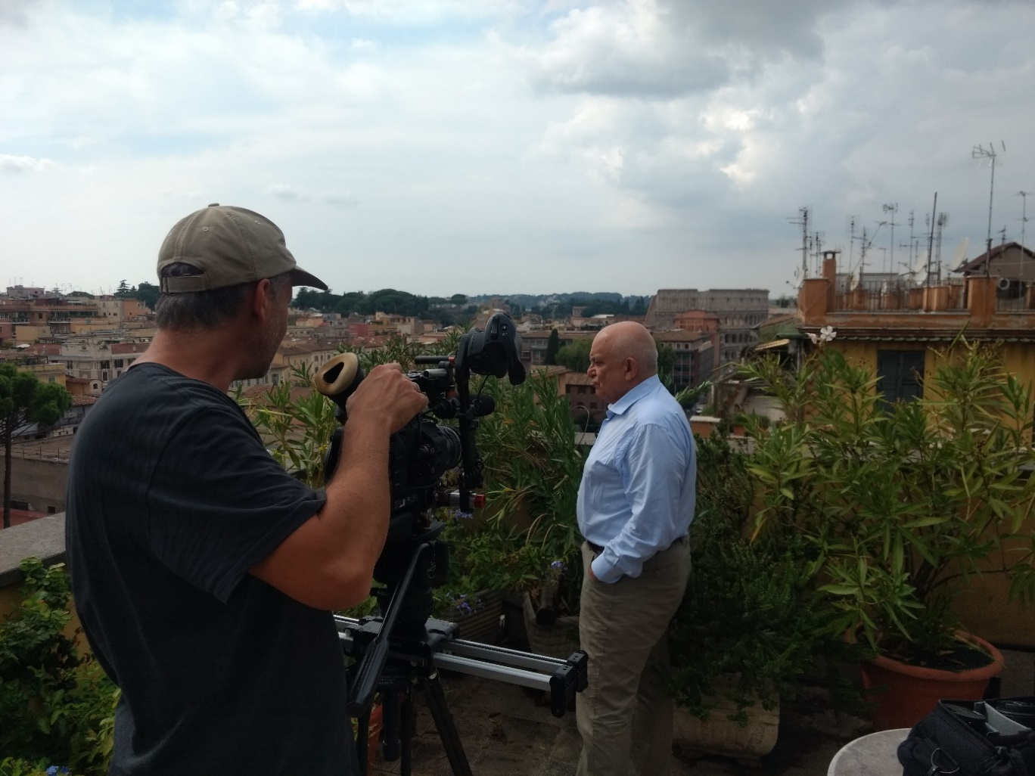
Marco d'Eramo on his terrace near the Colosseum: critical view of mass tourism. © NOW Collective 2019

Justinian Jampol

“Size matters because just of the enormity of it, the enormity of the scale. We're talking about a structure that was one of the, and still is, one of the largest in the world. I think the propaganda of the building, in a certain way is inescapable. And what I mean by that is architecture is inherently political. And the politics are embedded in the walls.“

Justinian Jampol was born in 1978 in Los Angeles, USA. In 2002, at the age of 24, he founded the "Wende-Museum" in Los Angeles and subsequently developed it into the largest collection of artefacts and art from the Cold War outside Europe. The museum has more than 100,000 exhibits from the GDR period alone, that reveal and classify everyday life and art, but also state oppression. During his studies of modern history at Oxford University, the son of Polish Jewish immigrants specialized in Russian and Eastern European history and philosophy. When people in Eastern Europe and the GDR sought to separate themselves from their past, Jampol's collection captured this lost history in a unique way. The collection places the objects in their historical context and captures what they meant for the people. A selection of them is presented in his encyclopedia "Jenseits der Mauer" (Beyond the Wall), which is over 900 pages long and showcases 2,000 exhibits on life in the GDR. For Jampol, Prora is also a symbol of past history. For him, the site subtly shows and illustrates the various epochs of German history that are brought to life in Prora.

Ulrich Busch

“Prora is the largest architectural denazification project of all times.
The object clearly had been a challenge for me and has become my life’s work in the end.“

Ulrich Busch, born 20 November 1964 in Berlin-Pankow, is a project developer and investor in Prora. He is the son of Ernst Busch, communist singer of workers’ songs and actor. His father became an icon in the GDR after narrowly avoiding execution as a prisoner of the Nazi regime. Behind the scenes, conflicts between the SED party leadership and the famous father repeatedly led to disagreements, which did not remain hidden from the son.
Ulrich Busch began studying medicine at Humboldt Universität Berlin in 1984, but was forced to give up in 1986 for political reasons. In 1987 he applied to leave for the Federal Republic of Germany because he no longer saw the GDR along the path of those values for which his father had once fought. It was not until February 1989 that Ulrich Busch was able to leave the GDR in exchange for handing over his father's artistic estate. After the fall of communism, Busch entered the real estate business as a project developer in the Baltic seaside resort of Binz.
In 2006, Busch acquired two blocks of the now heritage-listed "Colossus of Rügen" in Prora. In the following years, he even shaped building law through his negotiations with the municipality of Binz and the monument protection authorities. He opened the first hotel in newly renovated Prora in 2016 and renovated a total of around 370 apartments. As a project developer, he remains committed to the transformation of Prora, which he calls his life's work.

BIOGRAPHIES

Nico Weber (Writer, Director and Executive Producer), NOW Collective

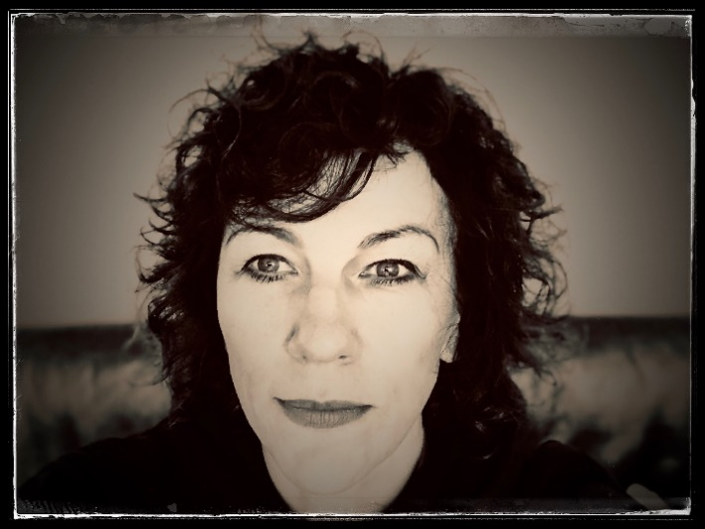
Director Nico Weber has been working intensively with Prora since 2015. Her film "The Ghosts of Prora. On the Reconstruction of History” (3sat 28.09.2015), aired to mark 25 years of German unity, was later broadcast under the title "Größenwahn in Beton" (Delusions of Grandeur in Concrete; 13.05.2016 ZDFinfo). Weber’s film took a bold approach to achieve a particular visual quality and complexity of content. Its focus was on German history from a German perspective, the transformation of Prora.
Since then, it has been clear that this was by no means the end of Weber’s preoccupation with Prora. In fact, she wants more: a more international and more essayistic approach, free of the shackles of ready-made TV programme slots. Moreover, Weber is well aware that the transformation of Prora is far from over, and even though media attention is growing, the complex itself has remained stuck in an exclusively classical historical view of Germany’s past.

The director's many conversations with local people, museum makers, former NVA officers, tourists, apartment owners, investors, project developers, architects, historians, artists and psychoanalysts, and her studies of numerous books, articles and films, have generated a great deal of attention; Prora is a very special, yet strangely forgotten place. One where the strands of 20th-century German history come together – National Socialism, the rise and fall of the GDR – and entwine with the threads of modern architectural history and the history of European mass tourism. Moreover, Prora is a metaphor for the strange entanglements and connections of historical time loops with human biographies; these indirect links often surprisingly emerge even when people do not have anything to do with Prora directly at first glance.

In this sense, INSIDE PRORA is a search for such connections and is based conceptually on architecture as a medium:

Architecture as a channel system that directs flows, as a communicative surface inviting interaction, as a shell that one attracts, or as an infrastructural matrix whose protocols can be circumscribed.

Nico Weber (*1967 in the northern Black Forest) is a director, author and producer – the latter with reluctance. Her choice of subjects is unconventional, her authorship clear. She works along the borderline between narrative film and other cinematic forms in search of the connection between a form and its content, in order to immerse herself in other universes.

Since studying philosophy, political science and German language and literature, she has worked on journalistic and artistic films primarily examining philosophical questions, above all the challenges of the supposedly "unfilmable"; in the process she has developed an associative and idiosyncratic film language that is permeated by a principle of radical subjectivity with an empathetic passion for her subject.

After working as a print journalist for "Die Woche" and as an editor and author for the current affairs editor at ZDF and for the programme Kulturzeit, she became a freelancer. For more than 20 years, her films for the public broadcasters in Germany, France, Austria and Switzerland have been shown on ARD, ZDF, arte, 3sat, ORF and SRF and have regularly crossed borders. Today she is engaged at the interface between film and visual arts and embarks on film trips throughout Europe, Asia and the USA with her company, NOW COLLECTIVE, working with artists in her field in camera and editing. She has received several awards for her films. INSIDE PRORA is her first work for the cinema. At the moment, she is working on her next cinema project, a film about "On Poetic Doing".
(www.nicoweber.com)

NOW Collective GmbH & Co.KG

NOW Collective was founded in 2019 in Berlin by Nico Weber, bringing together an international network of outstanding freelancers and cooperation partners in the fields of film, design, art and media. The collective has grown over more than twenty years in cooperation with nico weber_film.

NOW Collective sees itself as the strategic arm of a growing media collective that performs in various creative roles: developing and producing its own films for cinema and television as well as for institutions and companies worldwide, creating works of contemporary art, curating exhibitions, publishing texts and books, staging events, initiating processes. Its hallmark is first-class dramaturgical and visual quality in outstanding storytelling with a timeless character.

In 2019, NOW Collective completed the artistic documentary INSIDE PRORA (100 min) and presented the five-channel film installation FIVE MEDITATIONS ON DEATH at the B3 Biennale of the Moving Image in Frankfurt am Main. NOW Collective is also developing the film project “Zzyzx. On Poetic Doing” with the award-winning poet Oswald Egger and others.
(www.nowcollective.de)

Marc Nordbruch, Cinematography (ribozone)

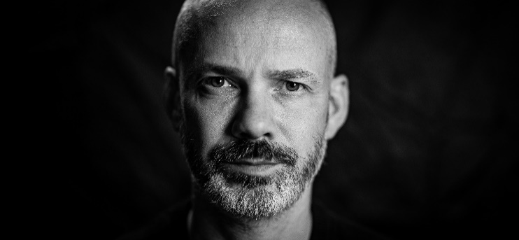

Born in 1972
1978 Started school
1991 Started training
enrolled in 1992 - believed to be musician, composer, photographer, video artist, filmmaker
1994 Trained as film and television editor
1998 Independent film and television editor
1998-2007 Worked, edited many documentaries, won some awards (you have to say yes)
2007 Expanded skills by adding camera work
Since then, freelance cameraman and editor
(www.ribozone.com)

Ralf Merten, Music Composer (Kubikmusik)

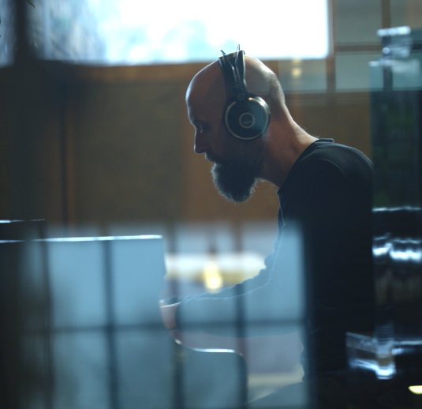
Born 1968 in Calw, Germany, Ralf Merten gained a Bachelor of Arts in Music from the University of Heidelberg and has worked as a freelance composer, artist and music producer since then.
In 1996, Merten’s groundbreaking debut KOBAT – Pieces For Prepared Piano (Source Records / EFA) was ranked as one of the top 10 best electronic albums by the German magazine SPEX. He opened the studio Kubik Musik in Cologne, releasing albums as an artist, songwriter and producer with his bands Elektrostar (WEA Records) and Linientreu (SONY Epic) as well as composing music for numerous advertising and TV projects. In 2000, he moved to Berlin to work as studio manager for the studio BL Productions where he wrote music for projects including TV animation series’ like Adventurers – Masters Of Time and MP4orce – Beyond Real.
These days, Ralf lives and works in Frankfurt am Main. He has completed notable projects such as the score for the film Nemesis (by Nicole Mosleh and starring Susanne Lothar and Ulrich Mühe), realized with the strings section of the Frankfurt Opera. He also composes music under the Kubik Musik label for brands including Braun, Alapé, Deutsche Bahn and Burmester.
(www.kubikmusik.net)

Lukas Schwarzkogler, Visual Effects Supervisor (MONTE NERO)

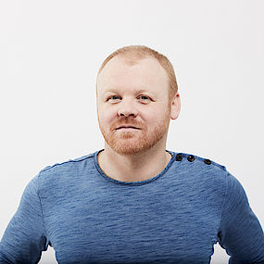
Creative Director at MONTE NERO Productions. After studying media and interaction design in Graz and Berlin, Lukas became acquainted with the agency business at Firstborn Multimedia in NYC/Manhattan as a motion design rookie. In 2007 he returned to Austria and co-founded the film company Airborne Motion Pictures, which he transformed into an award-winning company in his field of visual effects by 2017. Deciding to work freelance, he sold his shares and moved to MONTE NERO Productions to focus solely on his creative strengths as a DOP, VFX supervisor and motion designer. Since 2007, Lukas has also been a lecturer on visual effects at his alma mater, FH Joanneum. In addition to his expertise in commercials, he also has extensive experience in feature films and documentaries as a Visual Effects Artist.
(www.montenero.productions)

Jörg Leine, Line Producer (NOW Collective)

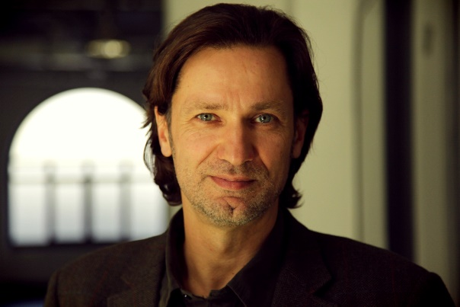
Jörg Leine (*1968 in Weimar) studied mathematics, journalism, political science and sociology in Jena and Berlin while already working as a freelance journalist. He was an editor at Bild-Zeitung in Berlin from 2000 to 2004 and then exercised the same function at the special-interest magazine Computer-Bild in Hamburg.

Jörg Leine returned to Berlin in 2014. Since then, he has worked as a freelance journalist, copywriter and author. Writing, however, was not the end of the story. For several years, he has also worked with his wife, director and producer Nico Weber, in the areas of editing and producing for film productions by nico weber_film and more recently NOW Collective GmbH & Co. KG.

These include the productions "Big in Japan – A Cartoonist in the Land of the Kanji” about the Viennese comic artist Nicolas Mahler (2015, 3sat), “The Ghosts of Prora. On the Reconstruction of History” (2015, 3sat/ZDF info), the series "Women of the Bauhaus – The Pioneers of an Art Movement" (2018, 3sat), nominated for the German Grimme Prize, and the feature film of the same name (ZDF, 2019). For "Inside Prora" Jörg Leine worked as an editor and, for the first time, also as a line producer.

While this was a great challenge, on the other hand parts of his own biography were also reflected there: from growing up in the GDR to military service in the National People's Army, the fall of the Berlin Wall and the Baltic Sea as a desirable destination.

PRESS RELEASE

INSIDE PRORA – TRAUMA AND DREAM

For the first time, Prora, the longest building in the world, is the protagonist of a film. Prora speaks to us. It recounts the darkest chapters of German history as well as the great existential questions to man and society.

Berlin, December 2019. Known as the "Monster by the Sea" and the "Colossus of Rügen", at 4.5 kilometres, Prora is considered the longest building in the world. Planned as a seaside resort during the National Socialist era, transformed after the Second World War into one of the largest barracks in the GDR – and long abandoned after the reunification of Germany. Nowadays, hotels and holiday apartments are emerging in the heritage-listed building on one of Germany's most beautiful beaches. Prora is evolving into a modern Baltic seaside resort.

This irony of history has prompted the Berlin director Nico Weber to take a new approach to the location. For the first time, she has made the longest building in the world the protagonist of a feature-length film. INSIDE PRORA is cinema at its best, forswearing a narrative voice. The film explores the complex and reveals its various historical, architectural and psychological layers. INSIDE PRORA makes surprising connections with this building between people and societies, modern architecture and the phenomenon of mass tourism. The film travels through space and time – but always returns to Prora. In stunning present-day and historical images, the director describes how the idea of Prora originated directly from role models in Italy and also establishes references to skyscraper architecture in New York.

INSIDE PRORA eschews an omniscient narrative voice. The film relies completely on the images of cameraman Marc Nordbruch, the music of Ralf Merten and a “cast” of people who are directly or indirectly connected to Prora.

They include: Top architect Peter Eisenman (USA), who designed the Holocaust Memorial in Berlin and once called for a return to the architectural modernity of the 1920s and 1930s; the last GDR defence minister and conscientious objector, Rainer Eppelmann; the Italian social philosopher Marco D'Eramo, whose mother, the well-known Italian writer Luce D'Eramo, first became a fervent supporter of Mussolini and later a communist; and Prora project developer Ulrich Busch, who sees it as his life's work to return the place to its original purpose. His father was the communist singer of workers' songs and GDR folk actor Ernst Busch, who narrowly escaped execution by the National Socialists.

Other experts of international standing supplement these views of the "Colossus of Rügen", including Justinian Jampol, historian and founder of the "Wende Museum" in Los Angeles (USA), the tourism researcher and historian Eric Zuelow from Maine (USA), and the Italian architect and architecture critic Vittorio Magnago Lampugnani.

The film celebrates its world premiere in 2020, 30 years after German reunification. This event is significant, offering food for thought for its makers, because INSIDE PRORA allows itself and the audience to play with completely new thoughts: Is Prora the happy ending to a story that has been overcome? Is Prora the irony of history – or its triumph?

All information available at www.inside-prora-film.de

INSIDE PRORA
D / I / USA 2019
Length: 100 Minutes

A film by Nico Weber
A NOW Collective production, Berlin
Writer, Director and Executive Producer: Nico Weber
Cinematographer: Marc Nordbruch
Original Music: Ralf Merten
Visual Effects Supervisor: Lukas Schwarzkogler
Line Producer: Jörg Leine
Editorial Collaborators: Jörg Leine, Heiko Kreft
Featuring: Peter Eisenman, Marco D'Eramo, Rainer Eppelmann, Ulrich Busch, Justinian Jampol, Eric Zuelow and many more

OPENING CREDITS

NOW Collective Presents

A Film by
Nico Weber

Cinematographer and Editor  Music Composer  Visual Effects Supervisor  Line Producer  Writer, Director and Producer | Marc Nordbruch  Ralf Merten  Lukas Schwarzkogler  Jörg Leine  Nico Weber

CLOSING CREDITS

Featuring  Writer AnD Director  Production  EDITORIAL COLLABORATORS  Cinematographer  First Assistant camera  drone photographer  Field Producers  Editor  Visual Effects Supervisor  Visual Effects Artists  COLOUR grading  Music Composer  Re-recording Mixer  Voiceover Artists  TRANScRIPTs  Translations  Legal Advice  Insurance  Archives  With special thanks to | Ulrich Busch  Wim Cox  Marco d‘Eramo  Peter Eisenman  Rainer Eppelmann  Antonio Ghionzoli  Romy Guruz  Justinian Jampol  Vittorio Magnago Lampugnani  Hendrik Liersch  Katja Lucke  Susanna Misgajski  Massimo Ricci  Eric G. E. Zuelow  Nico Weber  NOW COLLECTIVE  Heiko Kreft  Jörg Leine  Marc Nordbruch  Lorenz Brehm  Jens Habeck  Joseph Maggio  Philipp Schumann  marc nordbruch  Carmen Té (Italy)  Jörg Leine (NEW YORK)  Marc Nordbruch  Lukas Schwarzkogler  Marko Andrea Weiss  Andreas Mike Glatz  SVEN HAAS  Ralf Merten  BJÖRN WIESE  Oliver Brod  Jeff Burrell  John Jeffrey Collier  Romanus Fuhrmann  Corey Shank  Christian Steyer  Mike Trupiano  HANNAH BONDY  Gülçin KÖrpe  Alexandra HÖlzer  howden caninenberg  Archive of the Academy of Arts, Berlin  Bächtold Private Archive  dpa Picture-Alliance GmbH  Federal Foundation for the Reappraisal of the SED Dictatorship  Fondation Le Corbusier  German Broadcasting Archive  German Federal Archives  Heidrich Private Archive  Istituto Luce Cinecittà Historical Archive  Küchenmeister Private Archive  KURT WEILL FOUNDATION OF MUSIC  Looks Medienproduktionen GMBH  Meffert Private Archive  Praesens AG  Progress Film-Verleih GmbH  Prora Centre  Prora Documentation Centre  The Getty Research Institute  Transit Film GmbH  Ullstein Bild  UNESCO-World Heritage Ancient Beech Forests of Germany  VG BILD-KUNST BONN  Shelley Baranowski  Carolina Barwitzki  marikke behrens  Ulrich Busch  Donna Chin  Fabio Cifariello Ciardi  Maurice Cox  Cynthia Davidson  Luisa Eichhorn  Sylvia Griwan  Rüdiger Heide  Elgin Helmstaedt  MARTHA IHLBROCK  KOSTJA KÜNZEL  Nicole Pommerehncke  Bernhard Schmidt  Katrin Schwarzkogler  Antje Smigowski  Claudia Valentini  Holger Vonberg  Bauart  Binz Spa Administration  Corvinus Presse  Eisenman Architects  Emilia-Romagna Region  EUROPEAN SCHOOL OF management AND TECHNOLOGY BERLIN (ESMT)  German Youth Hostels,  State Association  Mecklenburg-Western Pomerania  Kubikmusik  Memorial to the Murdered Jews of Europe  Monte Nero Productions  Naturerbe Zentrum Rügen  Prora Solitaire  Prora Youth Hostel  Studio di Architettura  Vittorio Magnago Lampugnani  THE WENDE MUSEUM
“Urbanisme, projets A,B,C,H, Algiers, Algeria, 1930“ (Le Corbusier)
Photo: Lucien Hervé
© FLC/ VG Bild-Kunst Bonn 2019

“Urbanisme, projets A,B,C,H, Algiers“ (Le Corbusier)
© FLC/ VG Bild-Kunst Bonn 2019

Hanns Eisler: “United Front Song“
COURTESY OF THE GERMAN PUBLISHING HOUSE FOR MUSIC LEIPZIG

Hanns Eisler: “Solidarity Song“
COURTESY OF THE PUBLISHER C. F. PETERS LEIPZIG
AND THE GERMAN PUBLISHING HOUSE FOR MUSIC LEIPZIG

KURT WEILL / BerTOLT BRECHT: “mack the knife“
Courtesy of THE UNIVERSAL EDITION AG, VIENNA

A Film by
Nico Weber

INSIDE PRORA

A NOW Collective Production

© NOW collective 2019

Subtitles by
www.KOErpe.com

